**ACKNOWLEDGEMENT**

My initial thanks goes to the Industrial Tanning Division, University of Moratuwa, it’s director Mr. Ananda Gamage and the support stuff for arranging the industrial tanning programme which is a very valuable opportunity to engage and interact with the industry.

Also my heartiest gratitude does to Dr. (Mrs.) Dileeka Dias for being the initial coordinator for internship opportunity at the Singapore Management University. I also would like to thank the Electronic and Telecommunication Engineering department’s training coordinator Dr. Ruwan Udayanga Weerasuriya for guiding me at the most required moments during the training period. My sincere gratitude goes the department stuff, senior students and colleagues who though, guided and help me prior and during the training process to extract the best from the industrial training.

I would also like to extend my sincere gratitude to Associate Professor TAN Hwee Pink, Academic Director, SMU-TCS iCity Lab and Miss. Elina YU Jia, Assistant Director, SMU-TCS iCity Lab for selecting me as an intern at SMU-TCS iCity Lab. Also I am graceful to my supervisors Dr. Alvin VALERA, Research Fellow at SMU-TCS iCity Lab, Dr. TAN Hwee Xian, Research Scientist at SMU-TCS iCity Lab and Mr. Pius LEE Senior Research Engineer at SMU-TCS iCity Lab for guiding, mentoring and advising me though out the entire internship period. Also I would like to thank my fellow researches Miss. Xiao Ping TOH, Miss. TAN Lee Buay and Mrs. Cheryl KOH for the help and guidance given at the induction process. Finally I would like to thank Mr. Liming BAI and Mr. LA THANH Tam, Research Engineers at SMU-TCS iCity Lab for helping me with the technical aspects during the training.

I would like to thank the Singapore Management University staff for facilitating me though out the process. My sincere gratitude goes to the Singapore National Design Centre and iDA Lab staff for facilitating me with tools, equipment and fabrication facilities during the internship period.

Also my special thanks goes to Mr. Isuru Seneviratne and Mr. Udaya Roshan for coordinating the accommodation facilities in Singapore.

**Chapter 1**

**Introduction to the Training Establishment**

**1.1 Singapore Management University**

Singapore Management University (SMU) is a world class university established in 2000 with the mission of generating leading-edge research with a global impact. Singapore Management University is well reputed for its state of the art small size class rooms and interactive, collaborative and project-based teaching approach. The university is a home for about 9300 undergraduate, postgraduate, executive and professional, full and part-time students. University is comprised of six schools in the areas of Accounting, Business, Economics, Information Systems, Law and Social Sciences.



Figure 1

**1.2 TATA Consultancy Service**

TATA Consultancy Service (TCS) is established as a division TATA Sons Limited in 1968. The company incorporated as a separate entity in the year of 1995 while being a part of the India’s largest conglomerate, the TATA group.



Figure 2

TATA Consultancy Services is an IT services and consultation company which provides business solutions to organizations and business entities. The Global Network Delivery Model™ is one of the recognized industry bench mark developed by TCS in delivering IT services to its customers.

TATA Consultancy Services has more than 238,500 of the world’s best IT consultants over 45 countries. They handle more than 4500 IT contracts and have over 1500 more polled. The company operates over 13 European countries making it the Europeans #1 IT service provider in customer satisfaction. Currently the company has a combined value of 40 Trillion Euros making it one of the biggest IT service providers in the Europe Union.

**1.3 SMU-TCS iCity Lab**

**1.3.1 Brief History**

SMU-TCS iCity Labs was initiated as a joint venture of TATA Consultancy Services and Singapore Management University. TATA Consultancy Services had invested S$ 6 million at iCity Lab for research in cloud based IT solutions.



Figure 3

The idea of a new research lab to build cloud based service platforms came in the play in the mid of the year 2011. Due to the heavy investment by TCS the inauguration of the lab came in the August same year. After doing a feasibility study and a survey the first project idea was started in the month of November and deployed in March 2012. One of the key ideologies came at the days of inauguration by the initiators was to take a people interaction approach for the research and development work rather than in-house development. This idea was one of the key reason for the success of the lab and the one of the key features which distinguish the iCity lab from the rest of the research labs in the field.

**1.3.2 Research forces and functional goals**

SMU-TCS iCity lab was initiating as a research laboratory which will help to flourish the Singapore Government’s vision of ‘Smart Nation’. The labs main forces was to develop intelligent systems and platforms for Smart City ideas. Labs research forces could be categorized into four main areas.

1. Aging

2. Healthcare and Chronic Disease

3. Education and life-long learning

4. Employability

**1.3.3 Projects and present performance**

Neighbourhood for Active Living (NodAL) was a pilot project done with the collaboration of Eastern Health Alliance (EHA) to setup a community based care management system for the Singapore East. The main forces of the system was to take care of the patients (mainly elderly) after discharging from the hospitals. The care intervention was done though regular phone calls and visits to the houses by the volunteer groups. One of the key goals of the project was to reduce the frequent hospitalization due to lack of after hospitalization care. This actually transformed the manual paper driven healthcare to a collaborative iCare system.

iCity Visual Analytics Toolset is another project developed by iCity labs that could be used to business and social data analytics. These tools could be used to analyse data forecast future predictions and trends in the field of businesses social behavioural patterns.

SHINESeniors is the current ongoing project of iCity lab which is a Remote Elder Care Platform. The operational perspective of the project is to collect sensor data from the PIR sensors and door sensors for the analysis of human behaviour.

In the currently deployment the lab had implemented four PIR sensors and detect the motion of the elderly with in the house. There is a door contact sensor to detect the outing of the elderly from the house. Also a medication box with a sensor is installed to collect medication adherence data of the elderly. The bed sensor detects the sleeping patters which could be used to detect anomalies in the normal sleeping patters. Besides the sensors a Panic Button was provided to elderly to alter any panic attacks.

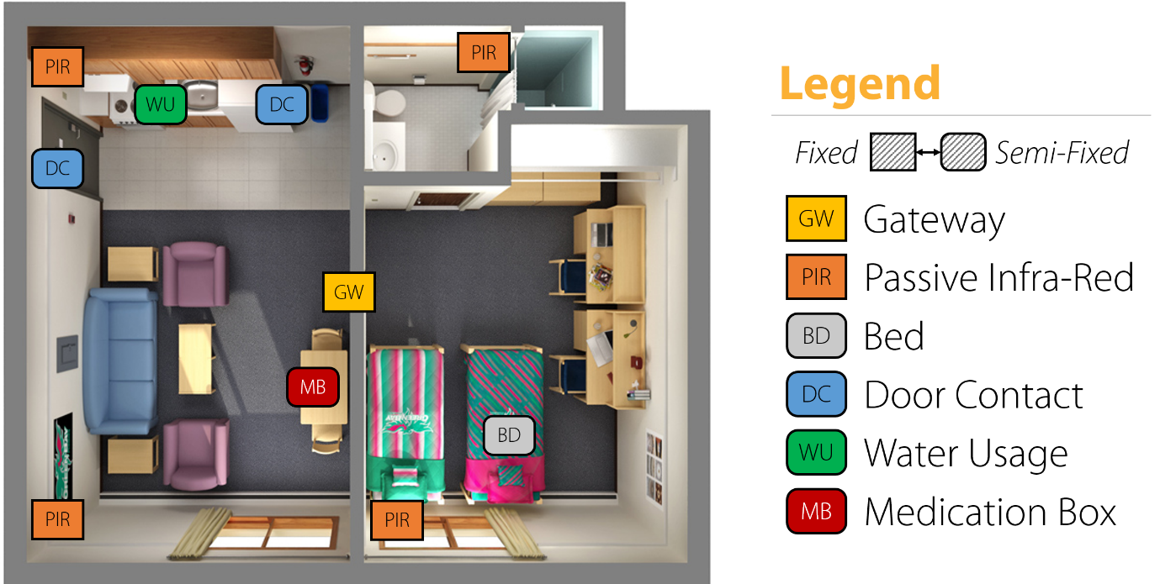

Figure 4

In the current modality a ‘No activity alert’ is triggered by analysing the PIR sensor data which is a suspicious call for the cases like elderly falling inside the house or fainting. Currently the distress alters are monitored by the iCity Lab staff and the Good Life, a volunteering association for elder care. In the future the operational power will be fully on the hand of the Good Life association.

Medication box is another interesting sub-project which is a part of the SHINESeniors project. The medication adherence data is quite useful for doctors in analysing the complications. Currently the elderly are alerted via a phone call if they miss any dosages. The lab is in the process of developing an automated process which could be monitored remotely by a care giver and make alters via a smart phone.

By the date the lab had complied 12 publications including two white papers. Due to the immense social impact the lab was able to secure a government grant of $ ……. For research and development.

**1.3.4 Organizational Structure**

Labs organizational structure is mainly into three main streams. They are Operations, Research and Development. Also the lab is monitored and by a two separate Steering Committee and an Advisory Committee.

**Steering Committee**

**Advisory Committee**

**Operations**

Senior Director

**Research**

Senior Research Fellow

**Development**

Chief Architect

Admin Officials

Student Interns

Research Scientists

Research Fellows

Research Interns

System Analyst

Developers

Interns

Figure 5

**1.3.5 Strengths and Opportunities**

Singapore government and health care associations are very much interested in the concept of ‘Ageing in Place’ which is a more sustainable solution for the growing population of elderly. Like most of the countries Singapore also faces the problem of imbalance population pyramid which will eventually lead to a huge elderly population in another 20-25 years. So the Singapore government had noticed this problem and currently promoting the ‘Ageing in Place’ concept. This is one of the main reasons that the iCity Lab started working on the SHINESeniors project as well. The government support is also one of the main strengths that the iCity Labs has. Also it is also a great opportunity for the lab to deploy a project like SHINESeniors.

TATA Consultancy Services is one of the biggest IT solution provider in the world. So in the initial dates the TATA consultation officers were helping the lab to start the projects and backing up the initialization process.

Besides TCS, iCity Lab is also collaborating with A-Star Research Company which the most reputed research institute in Singapore. With that collaboration, a considerable amount of knowledge, consultancy and help is flowing towards the lab. This is also a good strength that is available to the iCity Lab.

‘Lion Befrienders’ is another welfare organization which take care of lonely elderly. They also have a similar sensor system implemented at 500 elderly homes. Even though that they have the sensors, the organizations doesn’t do any ‘Behaviour Analytics’ with the data rather just alerting any when the elderly face any accident inside the house. So recently the organization made a partnership with the iCity Lab and start sharing the data. With that huge amount of data the lab was able to do more statistical analytics from the data obtained. This is a big opportunity for the lab in-terms of data.

**1.3.6 Weaknesses and threats**

Currently the sensor network was developed from off the shelf components. Also the hardware maintenance is done by a separate company. Because of this reason is researches find very hard to find some of the sensitive information. The problem is that the hardware company doesn’t disclose some of their sensitive information which is vital in analysing the data. Also too much noisy data is also another problem. Since the system is maintained by a third party the compensations are very small and the product vender doesn’t agree with some of the faults that the lab find from deep data analytics. This is one of the weaknesses that the lab currently has.

Since most of the people who are in the lab are from the research field the industrial exposure is very much less. So the industrial practices are not well practiced inside the lab which is another weakness of the lab.

Due to the aging population there are many organizations which are looking in the same type of solution which will be a threat in the future at the point of commercialization. Also a community project like SHINESeniors always should be backed by the government for its sustainable deployment. This also another threat that the lab is facing currently.

Besides that the iCity Lab can’t be the care givers or the responsible personalities to look after the elderly in the long run. Even in the current system the ‘Good Life’ association also play the care givers role. So this dependency on a third party is also another threat that the lab faces in the phase of implementing the systems.

**1.3.7. Profitability and usefulness**

SHINESeniors Project is mainly a community project which doesn’t expect much income from it. Even though that after the system is developed to a commercializable level it could be sold for a very high price due to the amount of analytics which was carried out in the developing process. The fact is that in Singapore iCity is the only research lab which does data analytics from the real life data for a considerable number of uses for a longer period. So these research data could be much more valuable than anything.

Ageing in Population is one of the upcoming problems in the entire world. Due to this fact in the near future the requirement of an elder care system will arise from the entire world. So there will be a very high demand for the eldercare system from countries outside Singapore as well. Selling the system to countries outside Singapore also will gain much profit for the lab.

The eldercare system developed by SHINESeniors project is very much useful for the elderly who live alone. In Singapore the birth rate is very due to the high expenses with in the country. So new families are much reluctant to have children. Due to this trend the country will end up with a considerable number of couple who doesn’t have children to take care of them. Also due to the busyness in the life the children will not have time to take care of their parents on site. So the developed system is a very good useful solution to both of the cases mentioned above.

**1.3.8. Suggestions and constrains to improve**

One of the key suggestions is to be independent in terms of development. Specifically the lab should maintain the hardware sensors so that the hardware too could be improved with time. Developing the hardware in-house is one of the solutions and the other is to use off the shelf sensors and assemble them in-house. Either way the lab will be having the required knowledge about the sensor specifications and will have the power to make adjustments when needed. This will solve most of the noise problems and data ambiguity that the lab is facing currently.

To deploy that idea the lab will need more experts on hardware as well. So with that expertise most of the currently facing problems could be solved. Also the lab should be equipped with industrial experts since they are dealing with a considerable number of hardware and software which should be more robust and accurate. Since the applications are more critical and mistakes could cost lives. This fact is very much important in the fully automated operational stage.

**Chapter 2**

**Training Experiences**

**2.0 Introduction**

SMU-TCS iCity Lab is a research lab consisting of a small number of highly talented researches doing research in human behaviour analytics. To do the research on the matter the lab had implanted the sensor system (Figure 1.xx) in 50 elderly homes in Marine Parade area. As a research intern I was able to engage in few research projects and numerous product developments. One of the initial day projects was to develop a low power RF transmitter and receiver pair using an Arduino Pro Mini, Raspberry Pi and two RF24 radio transceiver pairs. After that project I was assigned with a new project to retrieve data from SAMSUNG Gear S2. The device is loaded with the latest Tizen Wearable operating system which is a new system in the market. So the community support and other developer support is very minimal in which I had to work hard to get the things working.

All the other work was mainly based on the medication box which was deployed at the elderly’s homes. One of the initial work was on system integration and testing of the next version medication box. For that I was given some pre-written binaries to be integrated into systemd and test for the proper functionality. System testing consumed a lot of my time since some of the problems arouses after a prolonged operation of the system. Recreating the same problem was very much time consuming and tedious. For the given system the developers were not able to come up with a stable and device independent 3G connection driver which led to another task for me. Due to this problem I had write a stable 3G connection driver for the 3G dongles which run in Raspberry Pi. After that implementation I carried out some rigorous testing and over few weeks and finally an on-site testing which came out with very good results.

In the mean time I also wrote a Bash Script which could be used to make multiple copies of the SD card by installing the applications and making all the custom configurations automatically. The implemented system took a newer approach which is about 80-90% more efficient that the simple ISO image copying techniques. Few design iterations too was carried out with more added features like copying some of the files directly from the server as well. Also I made a simple power circuit using N-MOSFETs which is to be used with the Raspberry Pi to solve a voltage level and current limiting problem to light a set of LEDs. Also wrote a very stable and fool proof algorithm to be work with the ‘reed switch’ in the same design iteration.

On my last days I worked on a Bluetooth Beacon project which is to be used with the Raspberry Pi. It was another implementation for the older MedBox with more added features and some more functionality and data that could be used for Human Behaviour Analytics.

In the days of my internship I was able to participate to a seminar, a conference, a field visit and two exhibitions. My initial participation was to a Singapore-Sweden excellence seminar in ‘Ageing Societies and Innovative Ideas’. Then I participated to an IoT get-together which was hosted by SMU-TCS iCity Lab. After that I visited the Fabrication Laboratory (FabLab) of Singapore University of Technology and Design (SUTD). On the same day I also visited the Computer Science Department of Nanyang Technological University (NTU). The next outbound event was the Singapore’s ‘Future of Us’ exhibition hosted by the Singapore government showcasing the future government plans to improve the quality of living through technological innovation. I participated to the event as an exhibitor. After that I was lucky enough to participate to the IoT Asia 2016 conference as a student log-taker and as an exhibitor at the SMU-TCS iCity Lab’s stall. The experience gained at these events was immense and the exposure is much valuable.

**2.1 RF24 Transmitter Project**

**2.1.1 Project description**

The project was to develop a low power data transfer system for the Medication box (MedBox) as an improvement for the currently prevailing XBEE module. One of the main problem of current XBEE is the high power consumption during data transmission. This make the 2000mAh batteries drain within 1-2 months of operation. So as a solution I was requested to design an ultra-low power system to transmit data from the medication box to the Raspberry Pi gateway. Since the transmission unit also need to detect the opening and closing of the box the sensor system too was needed to implement in the same system.

**2.1.2 Development methodology**

RF24 transceiver module was used for the purpose. It uses the ‘NRF24L01’ transceiver IC which is an ultra-low power IC for data transmission.

Specifications of the transceiver:

* 900nA in power down
* 22μA in standby
* On chip voltage regulator
* 1.9 to 3.6V supply range
* Up to 2Mbps on air data rate
* Ultra-low power operation
* 11.3mA TX at 0dBm output power
* 12.3mA RX at 2Mbps air data rate

Since the requirement was to make the entire mobile unit low power a low power controller also needed to be used. To achieve this, a low power version of an Arduino board was used. The controller uses the well-known ATmega328 IC which is more improved for the low power consumption purposes. The power specification of the ATmega328P IC are as follows.

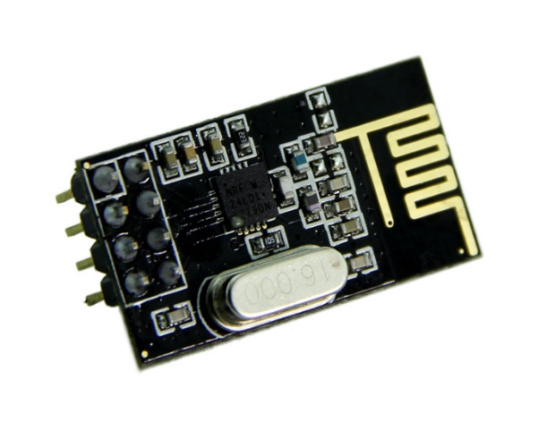

Figure 6: NRF24L01 transceiver module

* Active Mode: 0.2mA
* Power-down Mode: 0.1μA
* Power-save Mode: 0.75μA

Since the device is in its sleep modes most of the time of its operation, the Arduino Pro mini is a very suitable option for the purpose and the size of the board which is just $0.7 inch ×1.3 inch$ which make it more compact to fix inside the MedBox.

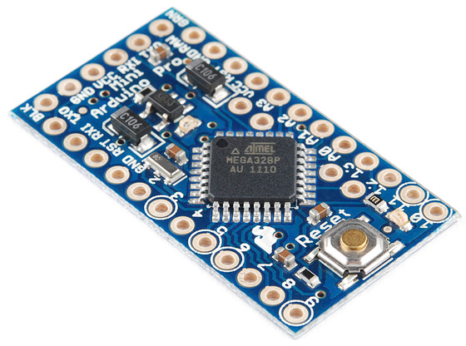

Figure 7: Aruino Pro Mini

After selecting the suitable hardware programming was started. The documentation for the NRF24L01 could be found at ‘tmrh20.github.io’ which is a very useful source to reference the operational information of the transceiver. Initially the sample codes given in the documentation web site is used to test the operation of the module. After initial testing the customization started. A two way handshake was implemented as the communication protocol. The previous iteration only had a one way handshake which is a burst of five packets of data which is not much robust in operation. The test performance of the developed system will be discussed by in the last paragraph of the subsection.

Arduino

Time Start

.

.

.

Time Stop

Raspberry Pi

Go to Sleep

Send Packet

Get ACK

Re-send Packet

Figure 8: Two way handshake implemented

The reed switched used in the system is a simple magnetic switch. It was mainly used due to its simplicity and long lasting nature when compared with a simple metal plate switch sensor. But the reed switch used to make a small bounce at its changes of state which should be removed either by using a hardware de-bouncer or a software de-bouncer.

After making the basic functions operational fine tuning and low power modes were added to the system. The system specification was to transmit a small ping every one hour and sensor data when an input is arrived. Besides all the time the system should be in the sleep mode or low power mode. To achieve this in the Arduino a Watch Dog Timer (WDT) was used with the sleep modes. But the problem with the timer was that the maximum time that could be set in the WDT timer is 8s. So achieve the low power performance it had to keep the WDT resetting until the required time is achieved. There is also a header developed by a third party called ‘Narcoleptic.h’ which does the same operation. But after doing so many tests it was found that there were some runtime bugs in the functions in the header, so I used my own sleeping function to get the work done.

Unfortunately the since iCity Lab is a data analytics lab the school is an Information System School the facility didn’t have any soldering facilities for me to solder some pins to the interrupt pins on the Arduino Pro Mini board. Due to this fact I was not able to proceed with the next step of the project which is de-bouncing of the input signal. The work was halted until I do the ‘Safety Briefing’ at iDA Lab which is a fabrication facility at Singapore National Design Centre.

**2.1.3 System testing the problems encountered**

As the first testing procedure I tested the receivers for its operational range. Since the boxes are located inside the house a very fair test was not able to be conducted due to the variation in the location specifications. So I tried for the worst possible indoor conditions so that we could make sure the proper functionality under any conditions. Indoor and outdoor tested operational ranges are as follows.

* Outdoor operational range: 50 m (Average)
* Indoor operational range: 15 m (Average)

These values are under normal power conditions of the transceiver which could be even maximized by using the max power mode. Since the tested values are good enough for the required specifications and running the system in low power is another concern the max power modes were ignored for the time being.

As a project management practice all the programmes were committed to Github repository for easy access, safety and versioning of the programmes. Developed programmes could be found at ‘github.com/bitandbytes/RF24-tranceriver-for-Arduino-and-Raspberry-Pi’

**2.2 Gear S2 data retrieval**

**2.2.1 Project description**

The final objective of the Gear S2 project is to develop a software platform to aid stroke patients to improve their motor skills. To do so, the project idea is to use the accelerometer in the SAMSUNG Gear S2 to detect the motion of the hand of the patient. Gear S2 is used due to its new advancements and comparatively longer battery life of the device.

So my work task is to retrieve accelerometer data and the heart rate data from the Gear S2 for the development platform.

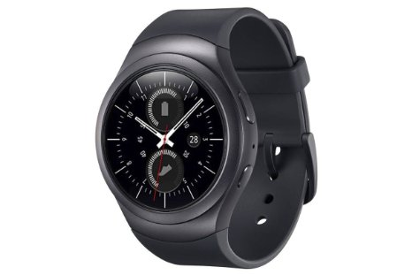

Figure 9: SAMSUNG Gear S2

**2.2.2 Development methodology**

The new SAMSUNG Gear S2 is running the new Tizen wearable operating system. Tizen wearable is a new alternative to android which is newly rising. Even though the Tizen is new to the market it has some very interesting security features. One of the noticeable feature is the safety in the developer mode. In the Android OS any person who has an .apk can side-load applications to the device. But for Tizen OS anybody cannot side-load applications directly. Only a developer can install custom applications to a Tizen OS since a certificate is required to install applications.

For this project even installing the IDE and the SDK is complex and misleading. Downloading and installing the infrastructure software itself took about 7-8 hours. Unlike Android, Tizen uses Java Script as the programming language and uses HTML5 to develop interfaces. Unfortunately, I am not familiar with Java Script as well as HTML5. So it took some time to get familiarize with the syntaxes and interfaces. After following a basic tutorial I started working on the project. With the guidelines given in the SAMSUNG developer site I was able to retrieve accelerometer data, heart rare monitor data and barometer data. Satisfied the initial request made by the supervisor and also in the meantime another intern too moved into the lab who is more familiar with Java Script and HTML. So the project was handed over to the new intern.

**2.2.3 Problems encountered**

One of the biggest problem that I encountered in the process is the lack of proper documentation and community support for the Tizen SDK due to its novelty in the market. That actually consumed lot of time going through different forums, blogs and support pages. Even though I am a bit familiar with Android and XML a bit moving towards Java Script and HTML5 too was time consuming since I was not familiar with the syntaxes. Also there was not body in the lab who was familiar in the subject so I was on my own during the entire process.

**2.3 MedBox Project**

**2.3.1 Project description**

MedBox is a simple medication box which was used to monitor the medication adherence of the elderly. The currently deployment of the box has a simple reed switch and an Arduino board as the driver. Then the singles from the Arduino is send to a ‘BeagleBone’ board (a Linux based small size computer) which act as the gateway to the system via XBEE interface. Then the data is send to an MQTT server which is operating in a cloud server via the 3G connection. Even though the collected sensor data is very small though proper data analytics it is possible to get very valuable results about the human behaviour.

One of the recent finding of the lab shows that any abnormalities in the medical adherence would show that the elderly is feeling sicker. Figure 10 is a graph extracted from a poster published by the lab.

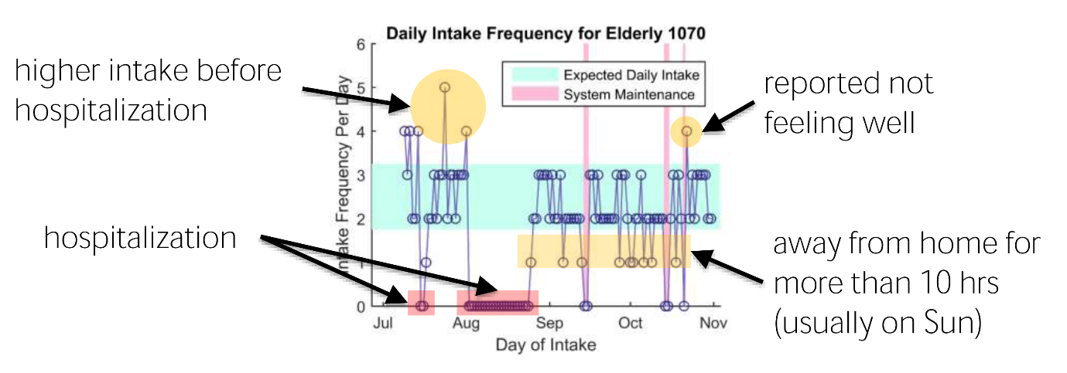From the graph (Figure 10) it is evident that there are some excessive medical intake in the month of July especially in the end of the month. In August the graph is flat where the elderly was hospitalized nearly ¾ of the month. After that the adherence levels are normal as it should be. After getting to know about the ground truth, the elderly was taking more medicine since she/he was not feeling well during the month of July. So technically it is quite possible to determine the abnormalities of the graph (Figure 10) which would tell that the elderly is not feeling well in the month of July. In the later iterations of the box more sensitive data was planned to collect and more behavioural patterns are to be determined which will be discussed later in the section.

Figure 10: Medical adherence graph

MedBox project is the main project which I was involved, and about 80% of my internship was focusing in improving the MedBox gateway and the sensing systems. I was mainly involved in the next iteration of the MedBox gateway and the sensor system using Raspberry Pi, reed switch and Bluetooth Beacons

**2.3.2 Development methodology**

2.3.2.1 System Integration

Since the pervious iteration of the MedBox system had a BeagleBone gateway the next version was to change the gateway to a Raspberry Pi due to its stability, performance and features. Get familiar with the Linux shell, systemd and other features my first task in the project was to integrate the BeagleBone service programme system into the Raspberry Pi. The system had xx number of service applications which are to be executed as services in the Raspberry Pi. The set of service programmes are as follows.

* XBee listener programme and an MQTT client
* MQTT server inside the Raspberry Pi
* Twitter service
* Remote MQTT publishing client
* Reverse SSH programme
* Service for 3G connectivity

The system was designed in a modular manner so remover the dependencies between the services as much as possible and making it able to develop parallely. Using the MQTT protocol is also a very important feature in the system due to its quality features which will be discussed later in the sub subsection.

Raspberry Pi

MQTT

Server

XBee listener programme and an MQTT client

Reed Sensor Input

3G Connectivity

Remote MQTT publishing

Reverse SSH

Twitter service

SSH Server

Remote MQTT Server

twitter.com

ISP

Figure 11: Flow diagram of the gateway